
APPENDIX 16
TEAM ENTRY PACK
INTRODUCTION

Welcome to the Basketball England’s NBL!

Whether you are a new club or a veteran entrant of the past 10 season, we are delighted to have you as part of our competitions this season. This document has been created to help clubs with all the administration required to guide their team through a successful NBL campaign.

The NBL provides performance-based club competitions that are available for senior and junior age groups across England. There are three tiers for age group competitions and multiple tiers at the senior level. These leagues assist in the development of the game and act as a stepping-stone into more performance-based competitions.

The aims and objectives of the NBL are to:
- Offer competitive fixtures and leagues across the country for all junior age groups and senior competitions, for both male and female participants.
- To increase and improve the quality of the players, coaches, and clubs in England.
- To develop, increase and improve the quality of match officials.
- To increase the awareness of basketball across the country.
- To provide a competitive environment for talented players that are a part of the Basketball England Performance Pathway.

The information contained in this pack including details of membership and licence fees as well as notable rules and regulations that are reviewed every season.

If you have any further questions on the contents of this pack then please get in touch with us via the contact details found at the end of document.

MEMBERSHIP & LICENCES
In order to participate in NBL competitions, all individuals must be affiliated Basketball England members and apply for a licence that reflects the role they will be fulfilling for the season. All membership and licence fees, for both senior and junior competitions, are listed below:
*Please note, membership and licence fees are subject to change each season.

NBL LICENCE FEES (includes membership)
NBL COMPETITION LICENCE (Includes as part of your membership price)
LICENCE TYPE | NATIONALITY | AGE | CATEGORY | FEE
Adult Player | National | 18+ | NBL – All Divisions | £75.00
Adult Player | Non-national | 21+ | NBL – All Divisions - Type 1 | £525.00
Adult Player | Non-national | 21+ | NBL – All Divisions - Type 2 | £160.00
Adult Player | Non-national | 18-21 | NBL – All Divisions | £75.00
Players 18 and under | All | Under 18 | Under 18  Under 16  Under 14  Under 12 | £40.00
Coach | All | 18+ | Senior NBL games | £75.00
Coach | All | 18+ | Junior NBL games only | £40.00
Bench Personnel | All | 18+ | All | £50.00
 | All | 18+ | Junior NBL games only | £32.00
Referee | All | 18+ | Senior NBL games | £80.00
Referee | All | 18+ | Junior NBL games only | £32.00
Referee | All | Under 18 | Junior NBL games only | £20.00
Table Official | All | 18+ | Senior NBL games | £50.00
Table Official | All | Under 18 | Senior NBL games | £40.00
Table Official | All | 18+ | Junior NBL games | £32.00
Table Official | All | Under 18 | Junior NBL games | £20.00
Statistician | All | 18+ | Senior NBL games | £50.00
Statistician | All | Under 18 | Senior NBL games | £40.00
Statistician | All | 18+ | Junior NBL games | £32.00
Statistician | All | Under 18 | Junior NBL games | £20.00
Note:
1. A FIBA fee will be added to any competition licences (if applicable).
2. Under 18 categories apply to those born between 01/09/2006 - 31/08/2007
Prices detailed in the table are our early bird prices. These will increase at a date on 30 September 2024.

After this date:
Prices for performance membership (which includes all NBL licence fees) will increase by £5.
Prices for participant memberships (which include all regional and local level competitions) will increase by £3.

REGULATIONS SUMMARY
The below information details the most useful and most frequently queried rules & regulations regarding participation in NBL competitions. It is important to note that there are more regulations than just the ones covered in this pack so if you are ever unsure on something please, check the rules and regulations document or contact a member of the Basketball England team before taking any further action.
The rules for senior and junior leagues differ in some areas so it is important to familiarise yourself with the rules that are relevant to the competition your team will be entering into.
All additional information can be found in the NBL regulations for the 2023/24 season via this link, though a new set of updated rules and regulations will be available for 2024/25.

GOVERNANCE
Affiliations – All clubs must ensure they are affiliated to Basketball England. Clubs can do this by paying the affiliation fee on the membership portal – (£80 for a junior club, £100 for a senior club) this will be the only option to enter your team.
If your club is completely new and entering a team into the NBL for the first time, you will need to register as a club here and ensure they have all documentation summited, this must be completed prior to the applying to compete in the NBL.
Team Names – All team names must include a specific geographical location (the county, city, or town where the team/venue is based). A nickname can also be included (Rockets, Magic etc).
Finance – All clubs must display adequate levels of finance to enable it to perform in a manner that is consistent with its status. The information in the ‘Fees and Finances’ section will help clubs with forecasting how much it will cost to participate in NBL competitions over the course of a season.

Fees & Finances
*The fees listed below are subject to change season on season.
All new senior teams must start in WNBL 2 for Women and the Conference Mens League for Men.
All new Jnr. NBL teams must start in conference/regional level of their respective age group competition.

TEAM ENTRY FEES
 | COST
Division One Men (inc. Cup & Trophy where eligible) | £850
Division Two Men (inc. National Cup) | £700
Division Three Men (inc. National Cup) | £620
Conference Mens League (inc National Cup) | £450
Division One Women (inc. National Cup) | £470
Division Two Women (inc. National Cup) | £420
Jnr. NBL – Premier League Entry | £160
Jnr. NBL – Conference League Entry | £140
Jnr. NBL – Regional League Entry | £120
Jnr. NBL – Under 12 competitions | £90
Sure Shot National Cup Entry (U18/U16) | £50

CLUB AFFILIATION FEES
 | COST
Senior Only Club | £100
Senior & Junior Club | £100
Junior Only Club | £80

NOTE: All clubs must pay a club affiliation fee at the start of the season, regardless of which competitions they enter.

Teams competing in Basketball England competitions are encouraged to establish a club-based approach to their structures. This means that the following are required:
- Appoint nominated volunteers into key positions and functions within the club (e.g., chair, club secretary, treasurer, marketing officer, fundraising officer etc)
- Consider financial sustainability, keep a monthly spreadsheet, and write down all income and expenditure. Is your club losing money?
- Coaches and assistant coaches must be level two qualified, be DBS checked and have a current safeguarding certificate.
- Organisation of courses within the club. Can you further develop your members to make the club more sustainable?

PARTICIPANTS
Individual Membership & Licencing
- All individuals must obtain the relevant licence to fulfil the role they are participating in the NBL.
- All coaches must be a minimum level two coach.
- NBL Division One coaches must hold a level three qualification.
- No player can be licenced to represent more than one NBL club. The exception is where a club does not have a senior outlet for a junior player and the individual is seeking to licence to ‘play up’ elsewhere from a junior age group team.
- No coach can be licensed for two clubs that compete in the same league or competition at any one time.
- Basketball England will set a deadline for individuals to be licenced by each season, with no licences or transfers allowed past that point.

Eligibility
- Coaches for junior teams must present a clear, enhanced DBS check and appropriate safeguarding training as part of eligibility requirements prior to being licenced.
- Players may play in senior competitions having attained their 15th birthday.
- Senior player eligibility is based on two categories, National and Non-National. Non-National is split into two types, with the following allowances per league:
NBL |  |  | MEN
LICENCE TYPE | NATIONALITY | CATEGORY | NBL DIVISION 1 |  | NBL DIVISION 2, 3 & CONFERENCE LEAGUE
LICENCE TYPE | NATIONALITY | CATEGORY | PLAY | REGISTER | PLAY | REGISTER
Player | National | Senior Player (18+) | Unlimited | Unlimited | Unlimited | Unlimited
Player | Non-National | Type 1 - Visa or work permitted required | 2 | 4 | 1 | 3
Player | Non-National | Type 2 - Settled Status/Pre-settled Status/ILR | Unlimited | Unlimited | Unlimited | Unlimited

WNBL |  |  | WOMEN
LICENCE TYPE | NATIONALITY | CATEGORY | WNBL DIVISION 1 |  | WNBL DIVISION 2
LICENCE TYPE | NATIONALITY | CATEGORY | PLAY | REGISTER | PLAY | REGISTER
Senior Player | National | Senior Player (18+) | Unlimited | Unlimited | Unlimited | Unlimited
Senior Player | Non-National | Type 1 - Visa or work permitted required | 1 | 3 | 1 | 3
Senior Player | Non-National | Type 2 - Settled Status/Pre-settled Status/ILR | Unlimited | Unlimited | Unlimited | Unlimited

Eligibility for Competitions:
Category | Born Between
Senior Players | 31/08/01 or earlier
Under 23 | 01/09/2001 -31/08/2004
Under 21 | 01/09/2003 -31/08/2005
Under 18 | 01/09/2006 – 31/08/2008
Under 16 | 01/09/2008 – 31/08/2010
Under 14 | 01/09/2010 – 31/08/2014
Under 12 | 01/09/2012 - 31/08/2015

Category | Eligibility
Senior | Eligible only to play in Senior competitions, a player must have attained their 15th birthday.
Under 20 | Eligible to play in Senior competitions.
Under 18 | Eligible to play in Under 18 competitions and above. Minimum age permitted is for the player to be attaining their 15th birthday from the 1st September 2024, this permits all players in school year 10.
Under 16 | Eligible to play in Under 16 competitions and above. Minimum age permitted is for the player to be attaining their 13th birthday from the 1st September 2024, this permits all players in School year 8.
Under 14 | Eligible to play in Under 14 competitions and above. Minimum age permitted is for the player to be attaining their 11th birthday from the 1st September 2024, this permits all players in school year 6.
Under 12 | Eligible to play in Under 12 competitions and above. Minimum age permitted is for the player to be attaining their 10th birthday from the 1st September 2024, this permits all players in school year 5.

FIXTURES
Arrangement of fixtures:
- No NBL/Jnr NBL fixtures shall be played on National Cup final dates in January.
- All matches shall take place at the following times (unless special authorisation has been given by Basketball England):
 | SATURDAY | SUNDAY | WEEKDAYS
NBL/WNBL | 13.00 – 20.00 | 13.00 – 17.00 | 19.30 – 20.00
Jnr. NBL | 11.00 – 18.00 | 11.00 – 17.00 | By mutual agreement
- For Junior National Cup and Playoff quarter final games, the earliest a game can tip for Juniors is 12pm, due to greater travel distances, unless mutually agreed between the two teams.
- The home team must confirm all fixture details with the away team at least two weeks before a match and the away team must acknowledge such confirmation. If confirmation hasn’t been received by the away team two weeks prior to the fixture, the game will still go ahead and the away team must make contact with the home team to establish if the details of the fixture are as per the Basketball England website (after 31st August).
Rearrangement, Postponement, Abandonment and Replaying of Matches:
- All requests to postpone fixtures must be made at least seven days in advance, must be in writing, and stating why the postponement is being requested. The request can either be agreed or rejected by clubs, in writing. This is so there is a paper trail of correspondence on the matter.
- The responsibility for notifying match officials of a postponement rests with the home club.
- A team shall forfeit a match if: fifteen (15) minutes after the scheduled tip off time, the team is not present on the court or is unable to field five (5) players ready to play save were, by agreement of all parties, a Match tips off late (e.g., as a result of travel delays).
Match Results:
- The scoresheet permitted in all fixtures (league, cup and playoffs) is the official running scoresheet only (FIBA/Non-FIBA copies permitted)

Legible electronic copies of a game’s scoresheet shall be uploaded by the home club to the Game Day management system to complete their result input or if required, emailed to Basketball England via competitions@basketballengland.co.uk no later than 48 hours following completion of the match. Basketball England shall be entitled to impose a fixed penalty in accordance with Regulation 49.16 for a breach of this Regulation.

PLAYING KIT
Team Uniforms:
- Team uniforms must comply with the official rules of basketball (as updated and defined by FIBA) http://www.fiba.basketball/documents
- Team uniforms may carry advertising subject to any requirement from time to time specified by, and the prior approval of, Basketball England.
- Each club must register details of its first-choice colours (vests and shorts) with Basketball England. The Home Team must always wear its complete, registered colours. It is the responsibility of the away team to ensure that its uniforms contrast sufficiently with those worn by the home team, and in any case of doubt, it is recommended that the home team have two alternative uniforms available. It is also recommended that the home team ensures that a set of uniforms, dissimilar from their own first-choice colours, are available at the venue, for use by them in case of an unavoidable colour clash.
Game Day Match Costs:
- Fill in the box below with your usual costs. This information will help you budget for staging an NBL game, which can then be used to work out the financial support required across a full season.
- Facility Hire (roughly 3 hours for set up, warm up, game time and any overtime, set down)
- Plus officials costs below
FACILITY HIRE | x3 hours court  @ £_________
OFFICIALS COST

TOTAL

MATCH OFFICIALS
Appointments and Expenses:
- All Match Officials operating in NBL and Cup Competitions must be licensed with Basketball England.
- For senior competitions (All leagues except NBL Mens Conference league), all Crew Chiefs and Referees will be appointed by Basketball England for each Match.
  - Junior matches require officials to be appointed by the home team, a list of officials in a local area can be provided by Basketball England in the event that a team cannot source their own.
- HMRC expects all payments to officials to be made by bank transfer or cheque. All officials are responsible for paying their own taxes and National Insurance and must comply with HMRC regulations. Payments by BACS must be paid within 7 clear working days of conclusion of the match. Where payments are not received on the 8th day, Basketball England will not appoint any officials to the next home game until payment is made. If no payment is made five days prior to the next scheduled match, then the game will be forfeited.
- For clubs who breach this on the second occasion they will be required to make payment in advance or on the day by BACS or by alternative payment option listed below.
- Payments made in cheque or cash must be made prior to the match.
- In the case where the home club appoint the match officials, they must meet the following criteria:
- Must be licenced with Basketball England as a referee,
- In the case that a referee is under 18, his or her co-official must be at least 18-years old, qualified (level 2 minimum), and licenced as a referee with Basketball England.
- No siblings/family taking part in fixture,
- Is not registered to participate in the same competition.
- The number of referees, at each level, that should be appointed to each league and/or playoff match should be as follows:

LEAGUE | N.O. REFEREES  (LEVEL 2) | N.O. REFEREES  (LEVEL 1)
Conference League Men | 2 | 0
Under 18 Premier & Conference  U16 Premier & Conference  U14 Premier | 2 | 0
Under 16 Regional  Under 14 Conference & Regional  U12 Leagues | 1 | 1

- The number of Table Officials, at each level, that should be appointed to each League and/or Playoff Match should be as follows, this includes 24 second operators:
LEAGUE | NO. TABLE OFFICIALS (LEVEL 3) | NO. TABLE OFFICIALS (LEVEL 2) | NO. TABLE OFFICIALS (LEVEL 1)
Division One Men | 3 | 0 | 0
Division Two Men | 2 | 1 | 0
Division Three Men | 1 | 2 | 0
Conference Mens | 1 | 2 | 0
Division One Women | 2 | 1 | 0
Division Two Women | 1 | 2 | 0
Under 18/16 Premier | 1 | 1 | 1
Under 18/16 Conference/Regional | 0 | 1 | 1
Under 14 Leagues | 0 | 1 | 1
Under 12 Leagues | 0 | 0 | 2

MEDICAL MATTERS
First Aid and Equipment
- The Home Club shall be responsible for providing suitable first aid equipment at the venue and all teams shall have a first aider present.
Blood Injuries
- During a Match, the Crew Chief must order any player who is bleeding, or has an open wound, to leave the playing area. The player may return to the court only after the bleeding has stopped and the area affected, or the open wound, has been completely and securely covered.
Anti-Doping
- Any person for whom a positive result has been determined in respect of the use of a prohibited substance (or refusing to take a test for such substances) shall automatically be referred to UK Anti-Doping, who will determine the appropriate penalty under the WADA code.
- If a player has been found to have committed an anti-doping rule violation during a competition, the result of the match shall remain valid. However, in such a case, the player in question shall forfeit any medals and prizes.
- In accordance with UK Anti-Doping Policy, where more than one member of a team has been notified of a possible Anti- Doping Rule Violation in connection with an Event, the team may be subjected to Target Testing during the Event Period.
- Furthermore, if more than two members of a team are found to have committed an Anti -Doping Rule Violation during an Event Period, this shall be treated as misconduct pursuant to the disciplinary rules for which an appropriate sanction shall be imposed on the team (e.g., loss of points, Disqualification from a Competition or Event, or other sanction) over and above any Consequences that are imposed on the individual participants committing an Anti-Doping Rule Violation.

FACILITY REQUIREMENTS
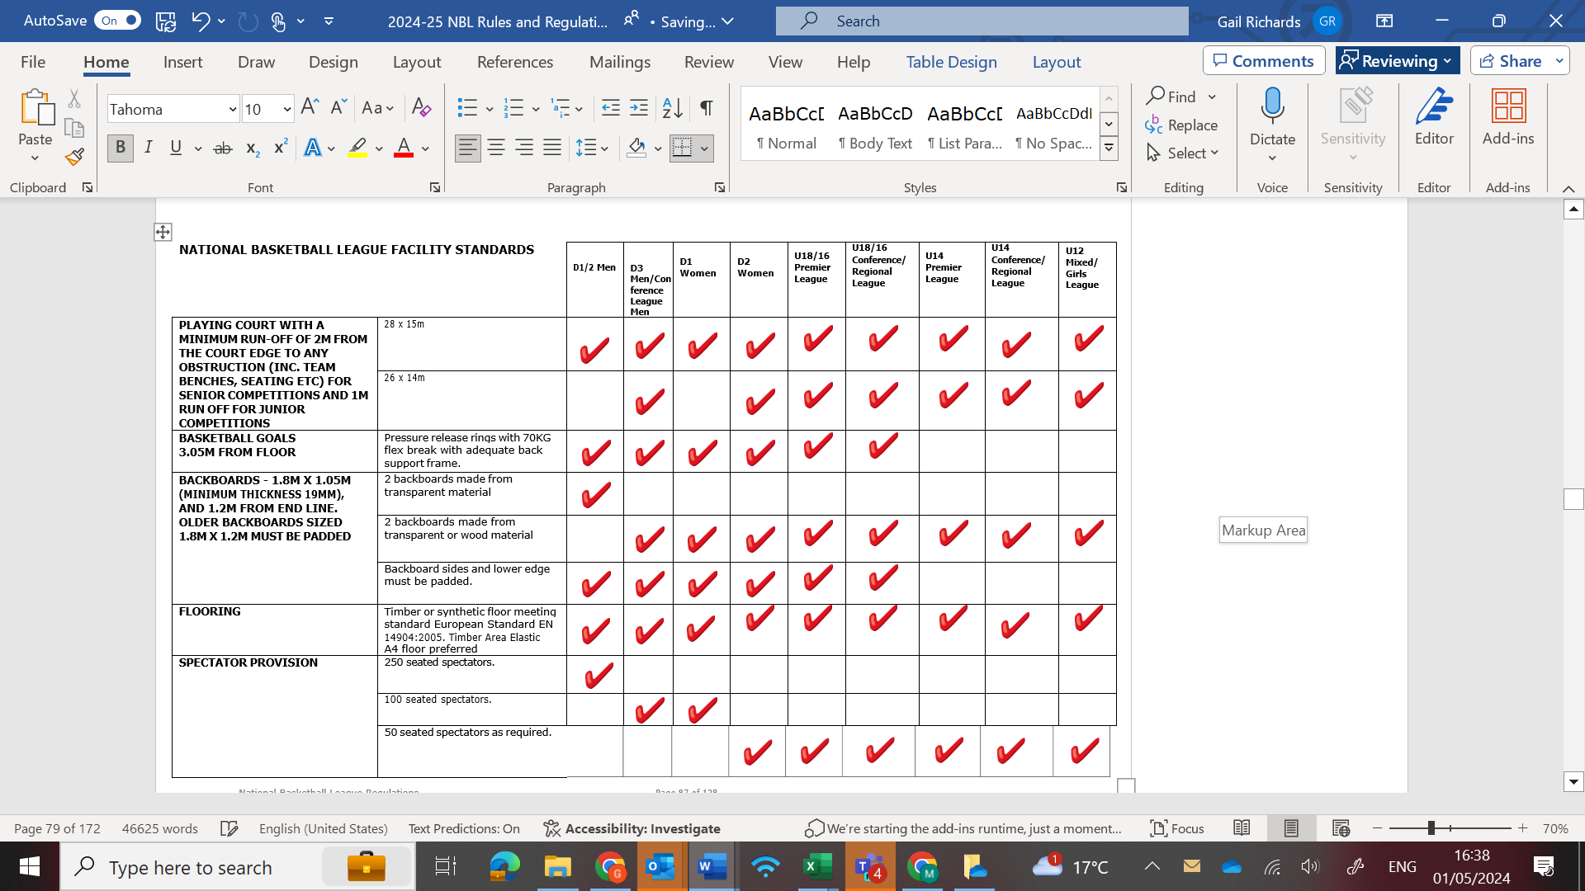

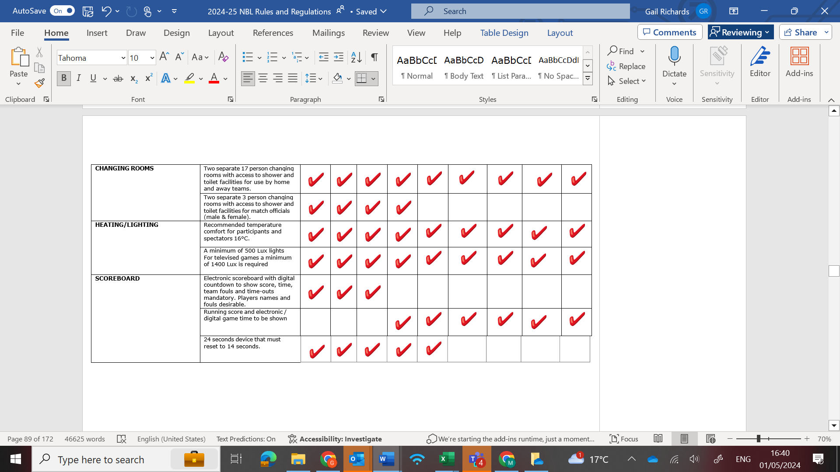

DISCIPLINARY, DISPUTES & FINES
The below outlines penalties that apply to offences committed whilst participating as a member club of the NBL. Some offences relate specifically to certain levels of competition, namely Senior Men and Women, so please read the specific regulation they refer to if you are unsure whether it would be applicable to your club.

OFFENCE | PENALTY
Failure to provide qualified and licensed Table Officials: (Regulation 41) | £40 per official and possible disciplinary action for the club
Forfeiture of fixture: (Regulation 24) | Senior:  See Regulation 24  Junior:  £100 - 1st offence  £200 – subsequent
Failure to attend the pre-match meeting and/or late arrival of team for pre-match meeting (5 players): (Regulation 26.5) | £50
Failure to upload scoresheet as required: (Regulations 30.1 and 30.6 as applicable) | £40 - 1st offence  £60 - 2nd offence  1 Pts deduction – subsequent
Failure to live webcast the FIBA Live Stats game as required: (Regulation 30.2) | £50 – 1st  £100 -2nd Offence  1 pts deduction -subsequent
Failure to update result service: (Regulations 30.4 and 30.5 as applicable) | £15 - 1st offence  £30 – subsequent
Failure to video and submit/upload the game tape to Hudl for game breakdown (regulation 30.3 and 30.8) | £150.00 – 1st offence  £250.00 – 2nd offence  £500.00 – 3rd offence and final written warning  Immediate expulsion from league – 4th Offence
Failure to provide refreshments where required: (Regulation 21.6) | £50
Failure to field 8 players: (Regulations 31.1) | £50
Failure to provide scoreboard / 24 seconds device: (Regulations 34.1 & 34.2) | £100
Failure to provide adequate stewarding: (Regulations 32.8) | £50
Fielding an Ineligible Participant:  (Regulations 17.9.4) | Minimum £500 plus consideration by the Competitions Review Panel
Failure to ensure branding & numbering shirts/court: (NBL standards) | £25 per offence
Failure to submit nominations for the ‘End of season’ awards when requested | £150.00 per team
Team arriving on the playing court up to 15 minutes after the scheduled tip off time: (Regulations 22.7) | £50

CONTACTS
The Basketball England team is here to service our members, Monday to Friday from 9am-5pm.
Should any clubs or individuals need support, please do not hesitate to contact us via the below.
Basketball England Office – 0300 600 1170
Email Address – competitions@basketballengland.co.uk

NEW TEAM ENTRY INFORMATION CHECK LIST.

In previous seasons, new entries would be discussed and verified by the regional talent managers responsible for the region the club was based in. However, as the regional talent model is currently being updated, we request that the following information is submitted to competitions@basketballengland.co.uk

In the boxes marked ‘Evidence’ please be as detailed as possible.

Thank you in advance.

Club Name:
Team Name:
NBL League(s) you wish to enter:
Person making application on behalf of club:
Entry Requirement | Evidence
The club has been playing basketball for at least one season in a competitive local league or other type of league, during a season where they play in a normal basketball game and not a shortened version:
There are key positions and functions within the club (e.g. chair, club secretary, treasurer, marketing officer, fundraising officer etc). Club constitution to be provided:
There is a club structure in place (e.g. seniors, youth teams competing locally or nationally) or are willing to develop such a club structure. Club development plan to be provided:
A team has more than ten players as current club members. Please list the players for the team you are wishing to make an entry for (or evidence of their club membership):
The new team has no effect on the current provision in place locally by another basketball club that is already established:
There are coaching staff, qualified to the correct level, DBS registered and with current safeguarding certificate. Please list the details of the coaching staff and their qualifications:
The club has appropriate financial sustainability and I can show previous accounts for the club:
The club has access to a venue that meets Basketball England Facility Guidelines. Please list facility to be used and provide details of the facility and how it meets the regulations. Is the facility registered with BE?
The club is organised and able to manage the administrational elements of being involved in an NBL competition, it has a dedicated club administrator and Team Managers for each team?
When making an application, the club understands that travel is required, and the club has the support to be able to transport players to away games as well as host home games:
The club has a minimum of two kits for the team to play in that are not contrasting and meet the rules and regulations of the competitions you wish to enter:
The club understands there are officiating costs in place (including transport/mileage) and often, depending upon the availability of local officials ,the cost of this can be high. This is also dependent upon the geographical location of the club:

Please add any other notes for this application to enter NBL that you feel are relevant.

